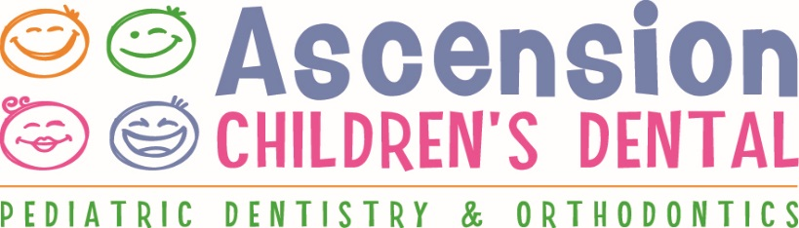

NOTICE OF PRIVACY PRACTICES
This notice describes how your dental information may be used and disclosed and how you can get access to this information. Please review this information carefully.

Our Legal Duty
We are required by applicable federal and state law to maintain the privacy of your child’s health information. We are also required to give you this notice about our privacy practices, our legal duties, and your rights concerning your child’s health information. We must follow the privacy practices that are described in this notice while it is in effect. This notice takes effect January 12, 2014 and will remain in effect until we replace it.

We reserve the right to change our privacy practices and the terms of the notice at any time, provided such changes are permitted by applicable law. We reserve the right to make changes in our privacy practices and the new terms of our notice will be effective for all health information that we maintain, including health information we created or received before we made the changes. Before we make a significant change in our privacy practices, we will change this notice and make the new notice available upon request.

Use or Disclosure of Your Health Information
For Treatment: We may use your health information to provide you with dental treatment and services. Information obtained by Ascension Children’s Dental will be included in your dental records that related to your treatment. Our office will also record dental treatment and services we provide for you in the course of your dental care and note how you respond to the dental treatment and services. Your protected health information can be provided to other health care providers for treatment purposes without restriction. This may include but is not limited to: other dentists, physicians, pharmacies, dental laboratories, and other health care providers involved in your treatment.

For Payment: We may use and disclose your child’s health information for purposes of receiving payment for treatment and services your child received. A claim may be sent to your insurance carrier. For your insurance carrier to make payment based upon your dental benefits coverage, information on the claim will include data that identifies you and your child’s treatment. Claims may be processed on paper or submitted electronically. Our office may contact persons other than the patient necessary to obtain payment for health care services. This may include, but is not limited to: Parents, grandparents, guardians, and collection agencies. Disclosure of only minimum necessary information will be provided.

For Health Care Operations: We may use and disclose health information about you for operational purposes. Your dental information may be disclosed to your dental insurance carrier to evaluate the performance of our dental practice, assess the quality of care and outcomes in your cases and similar cases, or learn how to improve our services to you.

Your Authorization: In addition to our use of your child’s health information for treatment, payment, or healthcare operations, you may give us written authorization to use your child’s health information or to disclose it to anyone for any purpose. If you give us an authorization, you may revoke it in writing at any time. Your revocation will not affect any use or disclosures permitted by your authorization while it was in effect. Unless you give us a written authorization, we cannot use or disclose your child’s health information for any reason except those described in the notice.

To Your Family and Friends: We must disclose your child’s health information to you, as described in the Patient Rights section of this notice. We may disclose your child’s health information to a family member, friend or other person to the extent necessary to help with your child’s healthcare or with payment for your child’s healthcare, but only if you agree that we may do so.

Person’s Involved in Care: We may use or disclose health information to notify, or assist in the notification of (including identifying or locating) a family member, your child’s personal representative or another person responsible for your child’s care, or your location, your general condition, or death. If you are present, then prior to use or disclosure of your child’s health information, we will provide you with an opportunity to object to such uses or disclosures. In the event of your incapacity or emergency circumstances, we will disclose health information based on a determination using our professional judgment and our experience with common practice to make reasonable inferences of your child’s best interest in allowing a person to pick up filled prescriptions, medical supplies, x-rays or other similar forms of health information.

Marketing Health-Related Services: We will not use your child’s health information for marketing communication without your written authorization.

Appointment Reminder Calls: We may use your child’s health information to provide appointment reminders or information about treatment or other dental-related benefits and services (such as voicemail messages, postcards, or letters). A reminder phone call may be left at your home or place of business to confirm an appointment date and time.

Required by Law: We may use or disclose your child’s health information when required to do so by law.

Abuse or Neglect: We may disclose your child’s health information to appropriate authorities if we reasonably believe that your child is a possible victim of abuse, neglect, or domestic violence. We may disclose your child’s health information to the extent necessary to avert a serious threat to your health or safety or the health or safety of others.

National Security: We may disclose to military authorities the health information of armed forces personnel under certain circumstances. We may disclose to authorized federal officials health information required for lawful intelligence, counter-intelligence, and other national security activities. We may disclose to correctional institutions or law enforcement officials having lawful custody or protected health information of inmate or patient under certain circumstances.

Your Health Information Rights

Access: You have the right to look at or get copies of your child’s health information, with limited exceptions. You may request that we provide copies in a format other than photocopies. We will use the format you request unless we cannot practicably do so.

Disclosure Accounting: You have the right to receive a list of instances in which we or our business associates disclosed your child’s health information for purposes, other than treatment, payment, healthcare operations and certain other activities. If you request this accounting more than once in a 12-month period, we may charge you a reasonable, cost-based fee for responding to these additional requests.

Restriction: You have the right to request that we place additional restrictions on our use or disclosure of your child’s health information by alternative means. You must make your request in writing & must specify alternative means.

Amendment: You have the right to request that we amend your child’s health information. Your request must be in writing. We may deny your request under certain circumstances.
Questions & Complaints
If you want more information about our privacy practices or have questions, please contact us.

If you are concerned that we may have violated your child’s privacy rights, or you disagree with a decision we made about access to your health information or in response to a request you made to amend or restrict the use or disclosure of your child’s health information or to have use communicate with you by alternative means, you may complain to us using the contact information listed at the end of this notice. You may also submit a written complaint to the U.S. Department of Health & Human Services.

We support your right to the privacy of your child’s health information.

